Contents

1.0 Abstract ………………………………………………………… 2

2.0 Design ………………………………………………………… 3

2.1 Website wide features……………………..………………………… 3

2.2 Home page features….……………………………………………… 4

2.4 About page features………………………………………………… 5

2.3 Portfolio page features……………………………………………… 6

2.4 Brands page features………………………………………………… 7

2.5 YouTube page features ……………………………………………… 8

2.6 Blog page features……………..…………………………………… 9

2.7 Gallery page features………….…………………………………… 10

2.8 Location page features………….………………………………….. 11

3.0 Conclusion ……………………………………………………… 12

1.0 Abstract

The purpose of this project was to build a mobile website to compliment an existing desktop version for graphic designer Jonathan Kelly. The mobile website had to integrate all the existing content and introduce new content via feeds. The mobile website incorporated many features from the desktop website including the following pages, portfolio, brands and about, while introducing new features like embedded feeds from, Wordpress, YouTube and Flickr. Further a social media share and like button were added. Finally the last thing incorporated that existed on the desktop version of the website was the Google maps page. Google maps was altered to be implemented on a mobile device.

2.0 Design

The mobile website was designed for easy navigation and a clear focus on content. Graphic design websites are often minimal on text and have a clean design, mobile websites have a similar style lending to the users simple interaction with the mobile website. The merging of both styles was easy as they both had similar backgrounds.

The website is design to have continuity across all pages, simple designs such as always having the home button in the same location. The design caters for intuition of the user. Nearly all objects on the website are clickable and interactive.

2.1 Website wide features

* Identical width content area
* Identical width header and footer
* Permanent navigational buttons
* Complimenting themes
* Identical font size
* Theme changer

After creating a website that was easy to navigate the next step in the design process was to showcase Jonathan Kelly’s work. Clicking the portfolio or brands link brings the user to a simple collapsible catalog of Jonathans work.

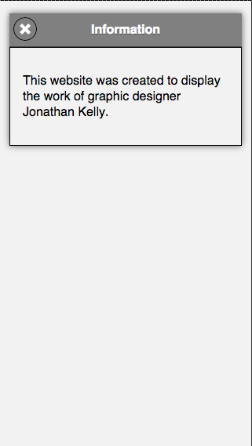

2.2 Home page features

* Header
* Navigation Bar
* Information Page
* Social media share button
* Facebook Like button
* Footer

The home page is the first page loaded when visiting the website. Although the URL for the website is the same on desktop and mobile, the content is different. This is achieved by using a simple JavaScript code that retrieves the device screen width and redirects the device to the appropriate site.

The index introduces the tone of the website to first time users and is important that the tone carries through out the website, this can be achieved by using similar styles and colors through out the website.

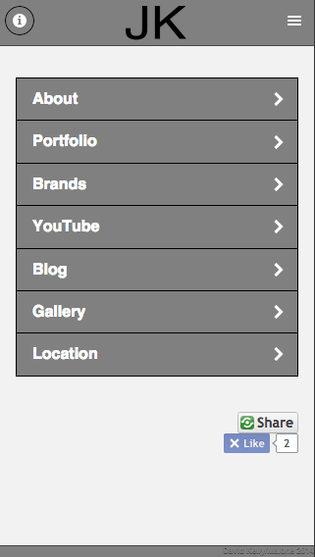 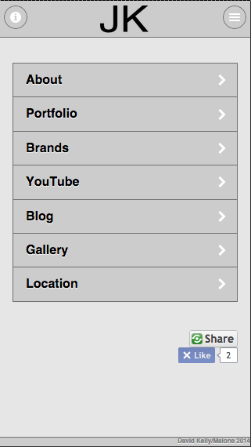

2.3 About page features

* Lists
* Collapsible data objects

The About page introduces Jonathan and his history in clean simple styles. Clicking on the education button will show a drop down list containing academic history. Career and Graphic Design buttons both contain paragraphs regarding Jonathan’s information to date.

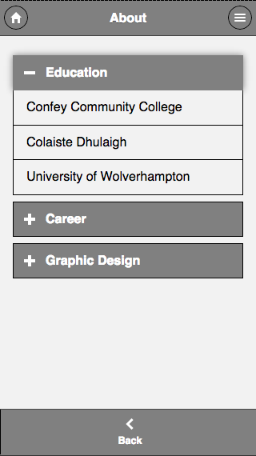 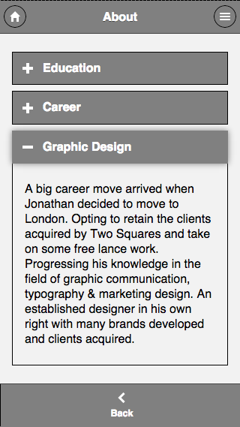

2.4 Portfolio page features

* Nested collapsible data object

In order to limit the users attention to as few fields as possible, when a user enters the portfolio page they will find the portfolio work broken in to sections. Within each portfolio section contains the information regarding the project and a further collapsible data object containing images from the project.

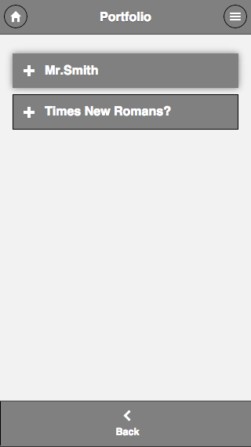 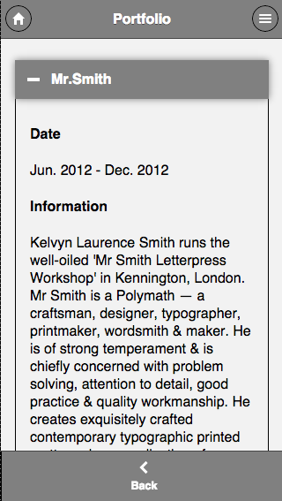

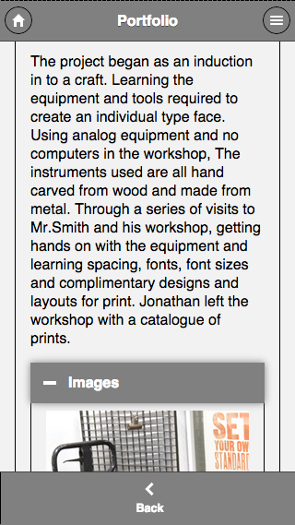

2.5 Brands page features

* Collapsible data objects

All the images from major brand projects Jonathan has worked on are contained within this page. All the images are sectioned and contained in collapsible fields to limit the information a user requests.

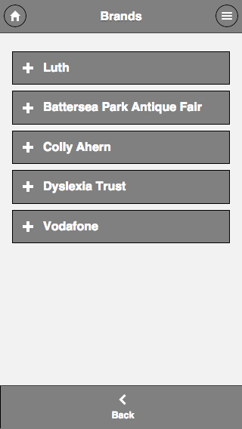 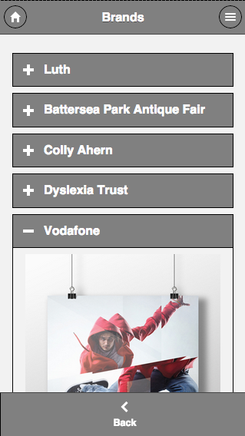

2.6 YouTube page features

* List of YouTube videos with title and description
* Embedded YouTube Player

Although Jonathan doesn’t have a YouTube channel, it was requested to be implemented on this mobile website for future use. The YouTube feed is read with JavaScript via the YouTube JSON REST API. As Jonathan does not have his own YouTube channel, the channel being retrieved is a respected user of the YouTube community that specializes in graphic design. The code retrieves his ten newest videos.

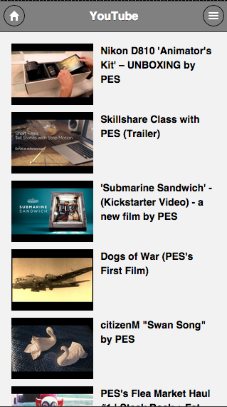 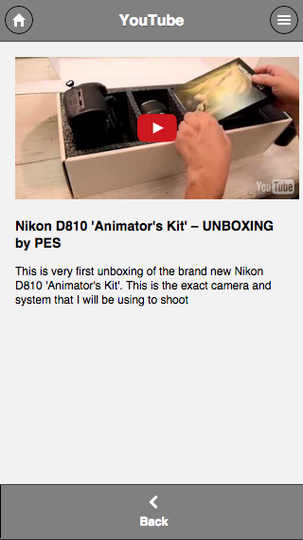

2.7 Blog page features

* List of blog entries form Wordpress with title and excerpt
* Contents of the post

The blog posts are read from Jonathans Wordpress blog and retrieved via the Wordpress JSON REST API. The content is displayed neatly through use of JavaScript. The Code does not have to be re written as the blog is updated or edited. The code retrieves the ten newest blog posts and feeds them to the website.

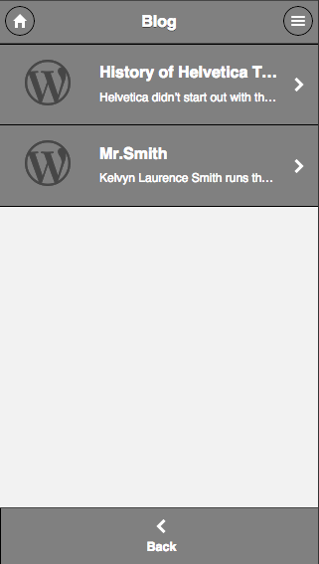 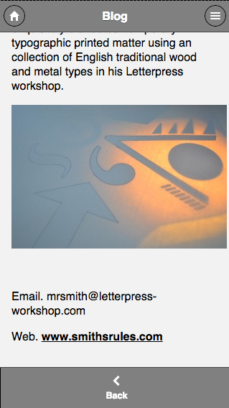

2.8 Gallery page features

* Flickr feed images

The gallery page contains a list of images retrieved from Flickr using the Flickr JSON API. Using JavaScript to display the contents as a list of images that when clicked opens a new page with a larger image. Clicking on that image will return the user to the list.

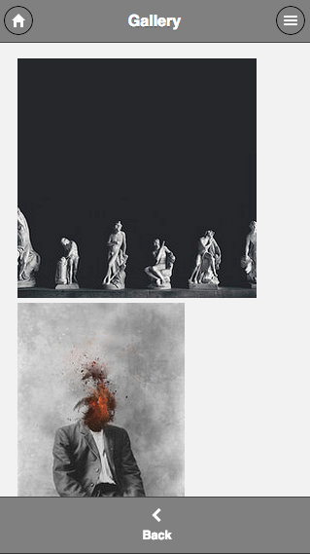 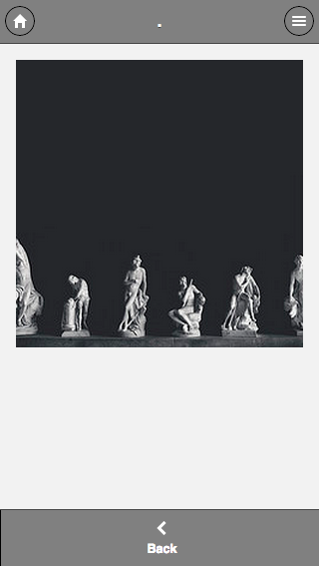

2.9 Location page features

* Google maps with markers
* Use current location / default
* Provide a route to Jonathans studio

The Location page is simply a map with markers for the users location and Jonathan’s studio location. The user is asked to use current location coordinates to find route. If the user decides not to allow the location services then Westminster Abbey is default setting. The user can zoom and change terrain features like a desktop version and also use street view. The map is requested from the Google API library and is created in the JavaScript file.

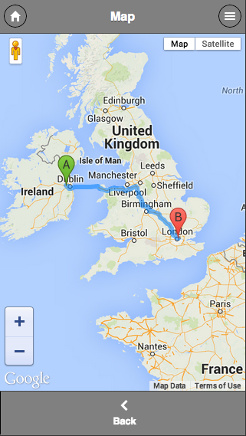 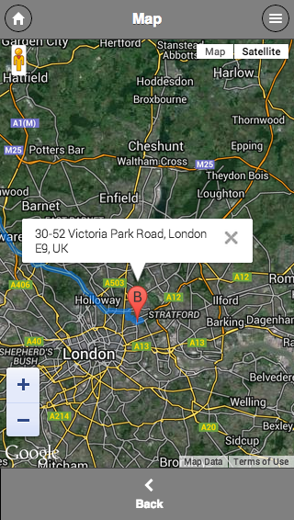

3.0 Conclusion

During the creation of this website we feel like we both had a good understanding of the technical skills involved. The skills that are new to us were the JQuery mobile features. Even though the JQuery features were new, they are well designed and easy to use. Using API’s to retrieve data via JSON was the most difficult challenge. Even though we had worked with JSON before the retrieval of data from external URL’s proved difficult but in the end achievable.

The project was difficult to implement all the features asked by the client but we feel that we have met the requirements and completed a functioning and well designed mobile website.